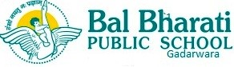
BBPS/GAR/PC/680/2023-24 1st November 2023
Dear Parents,
Greetings for the day!
The state government is conducting a State Educational Achievement Survey (SEAS) exam for the students of grade VI and IX, on Friday, 03-11-23. (Students should bring a black or blue ball point pen for OMR based examination.)
Reporting time - 7.30am,
After the examination students have to stay in the school for the practice of Annual function.
Students should bring their breakfast, lunch and water.
(It is mandatory for all the students to attend the examination)

Regards
BBPS TEAM GADARWARA

